Alfred Health Library Service

Introduction to EndNote 20

Training Notes (ver 1)

Table of Contents

- CREATING A NEW ENDNOTE LIBRARY

- IMPORTING JOURNAL TERM LISTS

- MANUALLY INPUTTING REFERENCES

- CHOOSING OUTPUT STYLES IN ENDNOTE

- ONLINE SEARCH (USING A CONNECTION FILE)

- DIRECT EXPORT OF REFERENCES INTO ENDNOTE

- IMPORTING REFERENCES (USING AN IMPORT FILTER)

- PDF’s

- GROUPS & RESEARCH NOTES

- USING ENDNOTE WITH MICROSOFT WORD

APPENDIX

- CUSTOM INSTALLATION
- ENDNOTE WEB & SYNCING LIBRARY
- PREFERENCES

HELP?

- The Help function can also provide assistance by clicking on Help on the menu.

- The extended list of import filters, connection files and output styles can be downloaded from www.endnote.com. This includes connection files for a number of local University Library catalogues.

- Monash University preferred Harvard style, and a superior Vancouver style can be found at : https://web.library.uq.edu.au/research-tools-techniques/referencing/referencing-software/endnote/output-styles

- CREATING A NEW ENDNOTE LIBRARY

  - Start the EndNote Program.
  - Select Create a new library from the popup; or use File>new
  - Create the name of your library, and choose location to save.

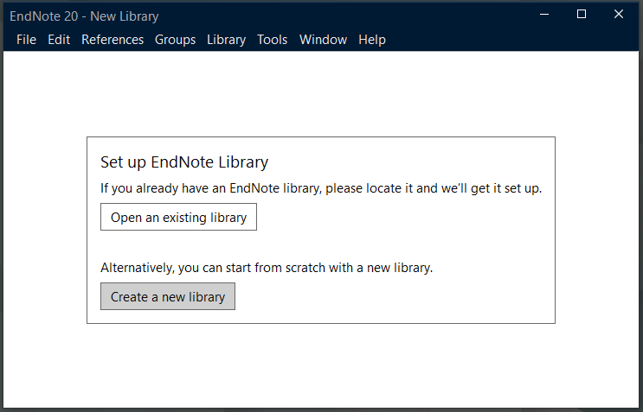

- JOURNAL TERMS LIST

To help EndNote correctly abbreviate Journal names it is useful to download the Medical journal “Term List” when creating a new EndNote Library.

  - From the Library menu, select Open Term Lists
  - Click on the Journals Term List, and select the Lists tab.
  - From the box select Import list.
  - Find the Term List directory which is located in the EndNote program folder ie c:\Program Files (x86)\EndNote 20\Terms Lists\ (Windows)
or Applications>EndNote 20>Terms>Medical.txt (MAC)
  - Click on Medical.txt and Open to import Term List.

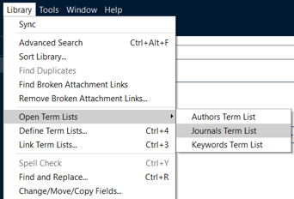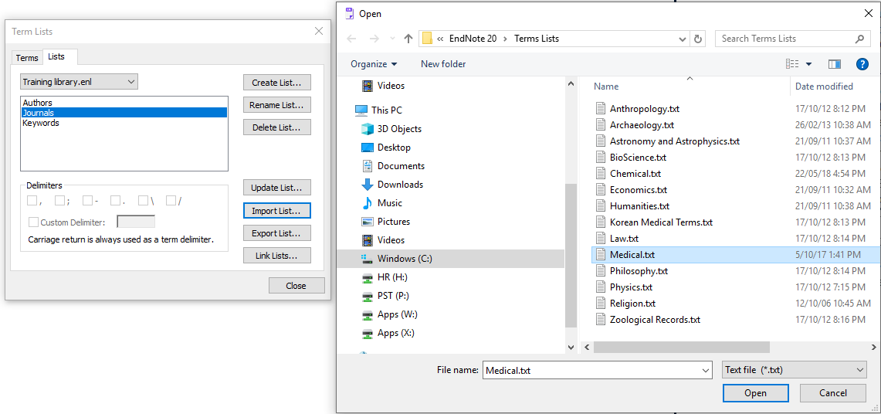

- MANUALLY INPUTTING REFERENCES

Although it is much faster to input references (citations) using bibliographic databases, sometimes references from books or journals will need to be typed into your EndNote library manually.

  - Click the + icon; or select New Reference under References
  - Select type of reference from the pull-down box, Journal Article, Book or Webpage are the most commonly used.
  - For example type in the following Journal reference :

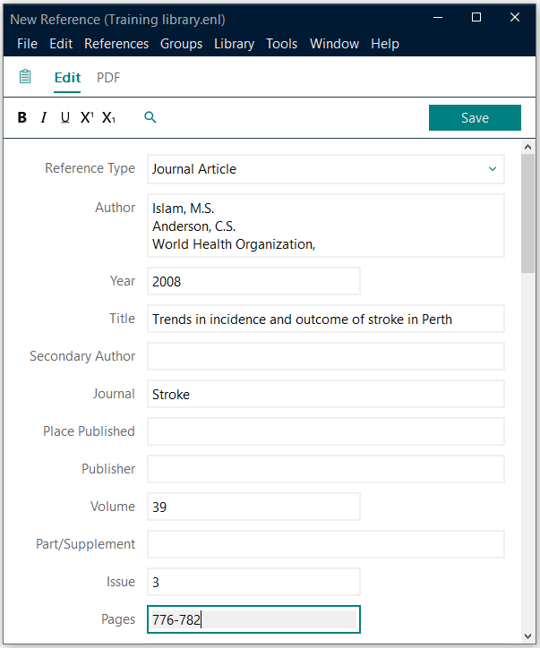

  - When the reference is completed you will need to click Save.

TIP : To input organisations as authors put a comma at the end of the organisation name ie : World Health Organization,

TIP : If your reference is not from a journal will need to change the Reference Type to the applicable source, such as book, book section, webpage etc.

EndNote fields used for Book reference:  Author  Bonita, R.  Beaglehole, R.  Kjellstrom, T.  Year  2006  Title  Basic epidemiology  Place Published  Geneva  Publisher  World Health Organization  Edition  2nd  Reference when formatted for Vancouver style:  Bonita R, Beaglehole R, Kjellstrom T. Basic epidemiology. 2nd ed. Geneva: World Health Organization; 2006.  Reference when formatted for Harvard UQ style:  Bonita, R, Beaglehole, R & Kjellstrom, T 2006, Basic epidemiology, 2nd edn, World Health Organization, Geneva.  Reference when formatted for APA 6th style:  Bonita, R., Beaglehole, R., & Kjellstrom, T. (2006). Basic epidemiology (2nd ed.). Geneva: World Health Organization. | Fields used for Webpage reference:  Author  Quit Victoria,  Year  Title  Nicotine replacement therapy: questions answered  Place Published  Melbourne  Publisher  Quit Victoria  Access Year  2018  Access Date  22 June  URL  https://www.quit.org.au/  Reference when formatted for Vancouver style:  Quit Victoria. Nicotine replacement therapy: questions answered. Melbourne: Quit Victoria; [cited 2018 22 June]; Available from: https://www.quit.org.au/  Reference when formatted for Harvard style:  QUIT VICTORIA. Nicotine replacement therapy: questions answered [Online]. Melbourne: Quit Victoria. Available: https://www.quit.org.au/ [Accessed 22 June 2018].
- CHOOSING OUTPUT STYLES IN ENDNOTE

Journals and Books require references to be recorded in specific styles. The Vancouver style is generally used with journals, whereas the Harvard style is often used with books. More styles can be found by using the style pull-down box above the lower Summary panel. Use Select Another Style to see all available styles:

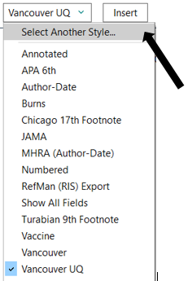
Note: styles can be further edited by going to :

Tools Output Styles Open Style Manager

After finding the specific Style required, select Edit and field to edit, such as Journal Name format, the citation template or bibliography template.

- ONLINE SEARCH (USING A CONNECTION FILE)

Databases such as Medline (PubMed) can be searched without leaving EndNote by using Online Search.

From the EndNote left side panel under Online Search click on PubMed (NLM)

The search screen will appear at the top of the screen.

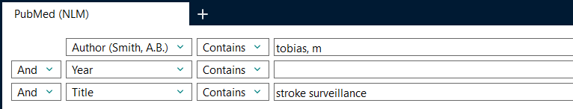

After doing a search, select which reference(s) you want to keep by clicking on a reference, and then add selected references to your local library by clicking the Plus symbol on the right-hand side.

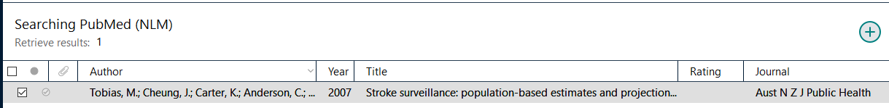

Within the list of Online Search connections (find under Tools tab) are many useful sites for finding book references which include :

- Monash University
- University of Melbourne
- National Library of Medicine
- Library of Congress

- DIRECT EXPORT OF REFERENCES INTO ENDNOTE

After completing a search of a database, references can be exported directly to an EndNote library. This process is supported by Ovid databases, PubMed, Google Scholar, and also many ejournals for direct export of individual citations.

The following screen examples are from Ovid Medline:

  - Select the Export option at the top of the results screen.

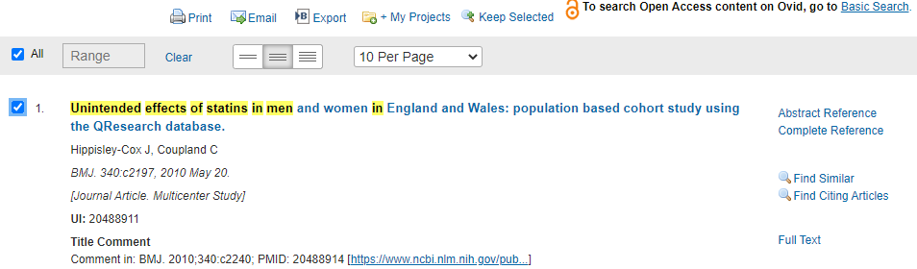

  - Select export to EndNote in the format drop-down box, and change fields to Complete reference, and click on Export :

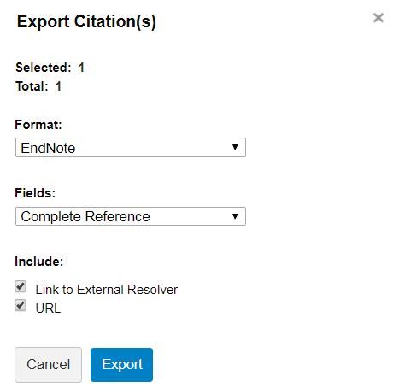

The following screen example is from PubMed:

When using PubMed.gov there is a method to export selected citations into EndNote, by using the Send to option, choosing Citation Manager for the destination, and clicking on Create File to start the process.

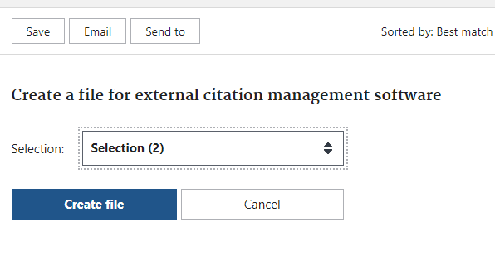

The following screen examples are from Google Scholar:

When using Google Scholar (scholar.google.com) you can use settings to choose EndNote as your Bibliography manager.

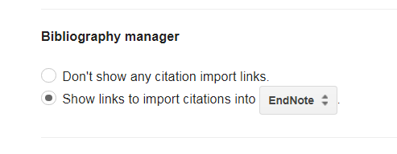

After completing a search use the Import into EndNote link under selected references to start the direct export process of the citation. Or if you are logged into Google you have the option to save multiple citations to My library and use the export all option to bring selected citations into your EndNote library.

- IMPORTING REFERENCES (USING AN IMPORT FILTER)

EndNote is able to import references which have been saved as a file when using databases such as PubMed or Ovid Medline.

Step 1 is to save references in the correct format when using a database so that EndNote can interpret fields when importing data.

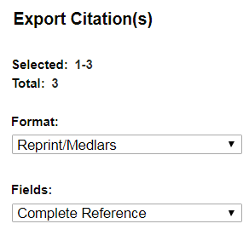 | Use the Export option to save  records in Ovid databases.  Select the Reprint/Medlars format before saving your records when searching Ovid Medline.  Choose Fields:  Complete Reference
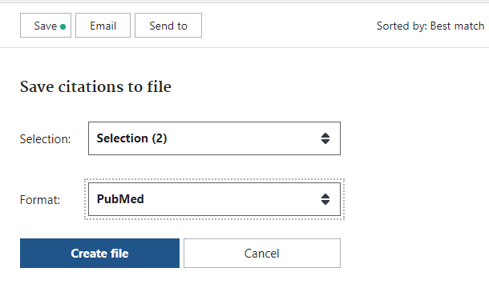 | When saving records in the  PubMed database click on the Save button, change Format to PubMed, and click Create file.

Step 2 is to import the file of references into EndNote, choose from the toolbar :

File Import Choose File locate file

From the Import Option list choose Other filters to find correct file format, then click on Import.

Common import filters : PubMed (NLM), MEDLINE (OvidSP), EMBASE (OvidSP), CINAHL (Ebscohost), PsycInfo (Ebscohost).

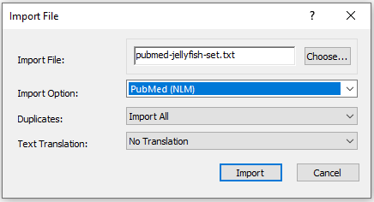

- PDF’s

PDF’s and ATTACHMENTS
If you wish to link references to PDF’s (or other document types), this can be done manually by highlighting a reference in EndNote and clicking the
+Attach File icon in either the Summary or PDF side panel:

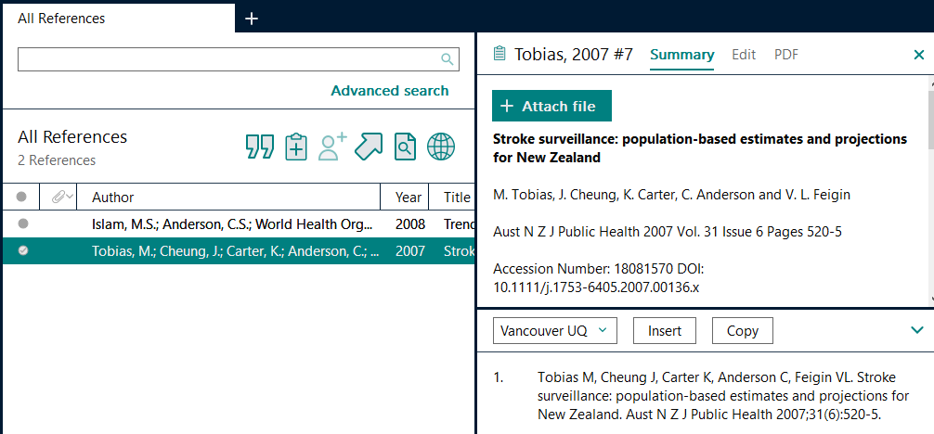

EndNote can also assist the searching and downloading references which are listed by highlighting the reference(s) of interest and then clicking on the Find Full Text ICON and the system will attempt to download the PDF document if possible. A successful download will be indicated by a paperclip icon next to the reference in the display.

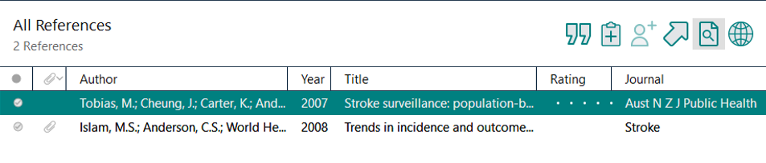

- GROUPS & RESEARCH NOTES

After you have successfully added references into your EndNote Library, individual references can be made more useful by adding research notes, or labels; creating EndNote groups, and linking full-text pdfs to references.

ADDING DATA TO FIELDS
Double click any reference and use the Edit tab to add your own information to fields within a reference, ie research notes, label, etc.

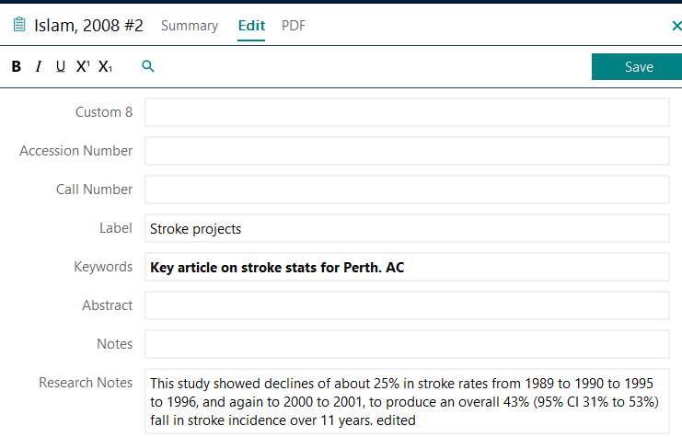

GROUPS
Under the Group tab at the top of the EndNote screen are options to create a Group, create a Smart Group, and create a Group Set. Groups allow you to manually group references together by dragging and dropping. Smart groups use a search profile to automatically add references into a group. Group sets are useful to help group references into topics, or chapters for a document.

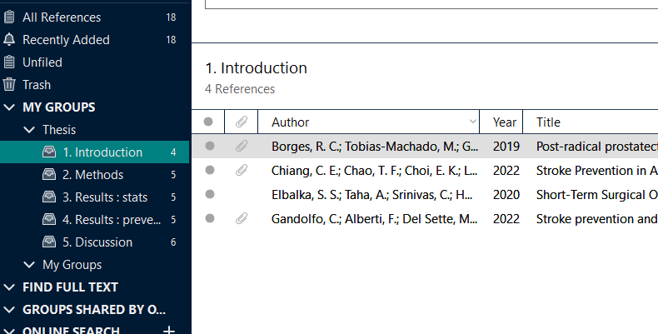

- USING ENDNOTE WITH MICROSOFT WORD

When EndNote is installed on a computer, an EndNote toolbar* is added to Microsoft Word. Icons are available to allow you to find references in your EndNote library and insert these as citations into your document.

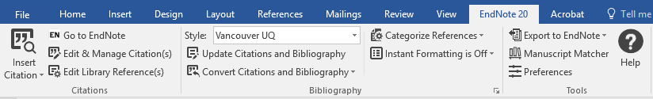

Important thing to note:

The Word EndNote toolbar controls much of the functioning of EndNote in your Word document. The toolbar can change the Output Style and control the formatting level of In-text citations. When using EndNote you cannot use Word’s inbuilt referencing system via the References tab to create your bibliography.

*The Word EndNote toolbar looks slightly different in the MAC version. Converting citations to Unformatted or to Plain text are under Tools.

Class Exercise :

Although stroke rates appear to be decreasing,¹ population ageing will intensify the disease and the need for effective management strategies.²

1. Islam MS, Anderson CS, Hankey GJ, Hardie K, Carter K, Broadhurst R, et al. Trends in incidence and outcome of stroke in Perth, Western Australia during 1989 to 2001: the Perth Community Stroke Study. Stroke 2008;39(3):776-82.
2. Tobias M, Cheung J, Carter K, Anderson C, Feigin VL. Stroke surveillance: population-based estimates and projections for New Zealand. Aust N Z J Public Health 2007;31(6):520-5.

MS WORD ENDNOTE TOOLBAR ICONS
Search + Go to EndNote Use these to find references you need to cite.
Edit & Manage Citations Move mouse cursor just before in-text citation marker, and click, grey highlight indicates citation can be edited.
Update Citations & Bibliography Use to reformat paper updating any citation deletions or changes to style, etc, Use to convert document from an unformatted state to formatted.
Convert Citations & Bibliography this is a pull-down screen with the following icons : Convert to Unformatted Citations This will remove the formatted bibliography references from your document, and convert the in-text citation to a format like {Smith, 2012, #13}. This will also switch off instant formatting. Convert to Plain Text Use this to convert your document to a safer format for proof reading and sending to a publisher for review.

Other useful controls can be found in the Format Bibliography options. To display the options click on the small down arrow to the right of the label “Bibliography”. Layout will allow you to change bibliography font and font size

You can change the style of your referencing by using the Style pull-down box. However if you need to change the format of your in-text citations or bibliography references for a specific style, this needs to be done via the EndNote program using Edit Output Style. There is a template for in-text citations and templates for reference types where small changes can be made to change the final look of citations and references.

Important features to explore are :
- Turning on and off Instant formatting option
- Using Update Citations & Bibliography to format document
- Inserting citations using different display options
APPENDIX

- CUSTOM INSTALLATION
EndNote 20 only installs a selection of the most popular filters, connection files and output styles by default. To install ALL available files:
1. Select the Custom option during installation.
2. Choose Entire feature will be installed on local drive from the pull-down menu of Additional Filters. Repeat the previous step for Additional Styles.

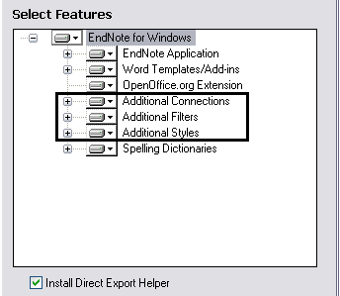

- ENDNOTE WEB
EndNote users have the option to create an EndNote Web account, which is very useful as either a backup of your PC/MAC version, or as a method of using EndNote entirely.

An account can be created at : https://access.clarivate.com/login?app=endnote

Under the Library tab users will find an option to Sync their library with EndNote Web to keep both versions uptodate. Login details can be stored in preferences.

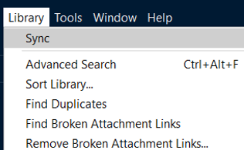

- PREFERENCES

EndNote preferences can be found via under the Edit tab.

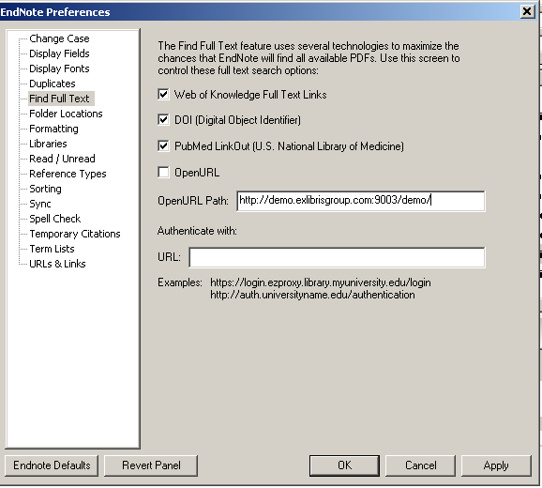

TIP : use preferences to :

- Change default display fields in the references summary screen
- remove OpenURL option if Find Full Text is not working
- store login details for EndNote Web sync function

